WEB TASARIM ÖDEVİ



SAKARYA ÜNİVERSİTESİ

Buğra Başaran G211210015

|  |  |  |  |  |  |
| --- | --- | --- | --- | --- | --- |
| HAKKIMDA | CV | ŞEHRİM | MİRASIMIZ | İLGİ ALANLARIM | LOGİN |

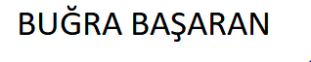

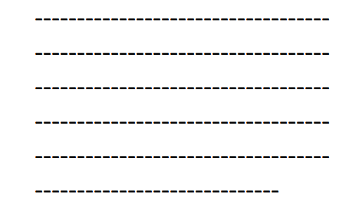

|  |  |  |  |  |  |
| --- | --- | --- | --- | --- | --- |
| HAKKIMDA | CV | ŞEHRİM | MİRASIMIZ | İLGİ ALANLARIM | LOGİN |



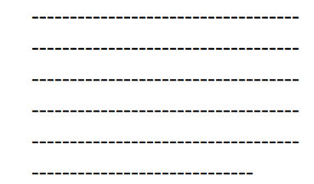

|  |  |  |  |  |  |
| --- | --- | --- | --- | --- | --- |
| HAKKIMDA | CV | ŞEHRİM | MİRASIMIZ | İLGİ ALANLARIM | LOGİN |



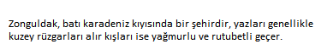

|  |  |  |  |  |  |
| --- | --- | --- | --- | --- | --- |
| HAKKIMDA | CV | ŞEHRİM | MİRASIMIZ | İLGİ ALANLARIM | LOGİN |



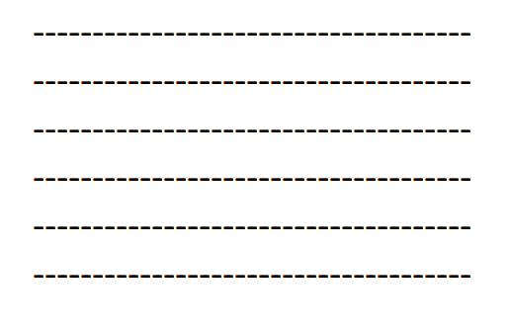

|  |  |  |  |  |  |
| --- | --- | --- | --- | --- | --- |
| HAKKIMDA | CV | ŞEHRİM | MİRASIMIZ | İLGİ ALANLARIM | LOGİN |

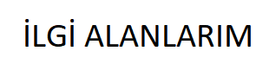

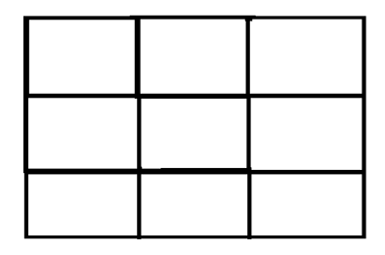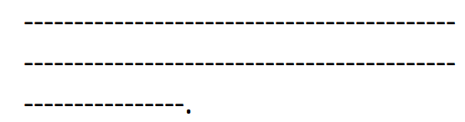



|  |  |  |  |  |  |
| --- | --- | --- | --- | --- | --- |
| HAKKIMDA | CV | ŞEHRİM | MİRASIMIZ | İLGİ ALANLARIM | LOGİN |

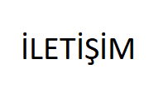

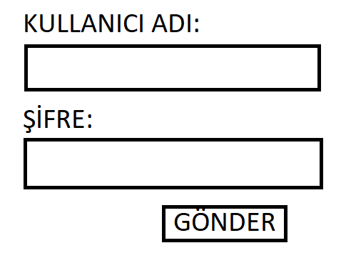

GİTHUB LİNKİM:https://github.com/basaraann/web-tasarim.git